**Lab VIII – Health Analytics I**

**Exercise 1**

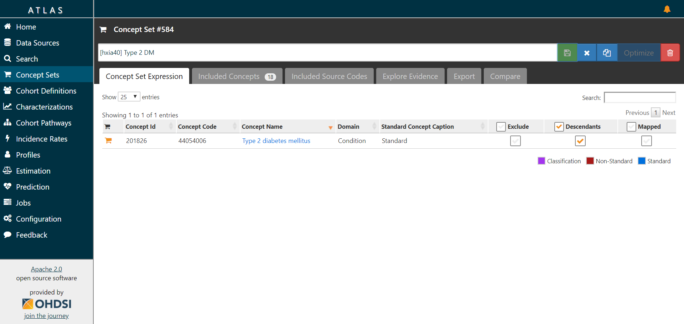

<http://gt-health-analytics-2.us-east-2.elasticbeanstalk.com/#/conceptset/584/details>

**Exercise 2**

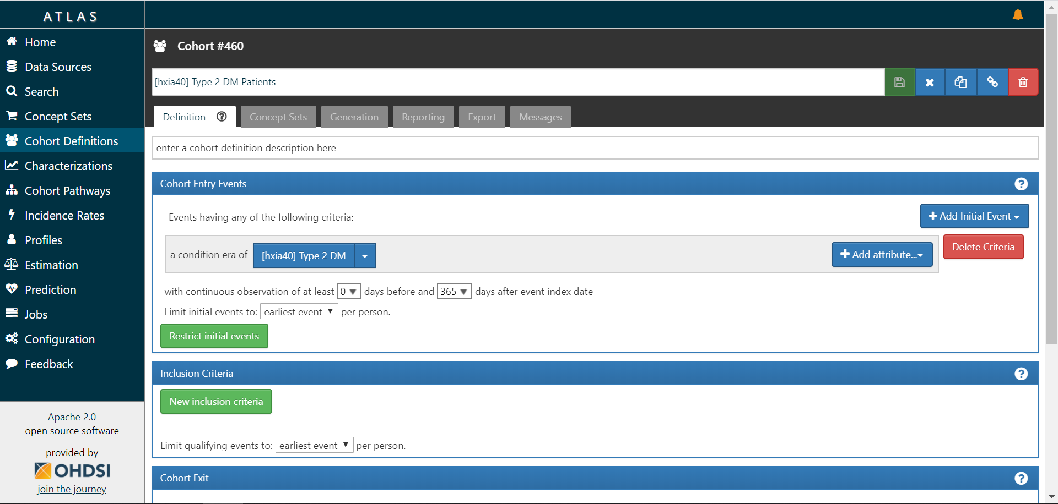

<http://gt-health-analytics-2.us-east-2.elasticbeanstalk.com/#/cohortdefinition/460>